**Machine Learning Assignment-01**

**Name- Nikhil Bonala**

**Student ID- 700745888**

**Google Drive link(Video) –** <https://drive.google.com/file/d/1NSVFR9poTl95RNhE93gGH2uOhNPjvb6H/view?usp=share_link>

**Github Link -**

<https://github.com/nikhilbonala/MachineLearning>

**Question 1**

The following is a list of 10 students ages: ages = [19, 22, 19, 24, 20, 25, 26, 24, 25, 24]

• Sort the list and find the min and max age

• Add the min age and the max age again to the list

• Find the median age (one middle item or two middle items divided by two)

• Find the average age (sum of all items divided by their number)

• Find the range of the ages (max minus min)

**Answer:**

#question1

ages=[19,22,19,24,20,25,26,24,25,24]

#1.1. Sort the list and find the min and max age

ages.sort() #used sort function to sort

min_element=ages[0] #as list already sorted taking first element as minimum and last element as maximum

max_element=ages[-1]

print("The minimum element in the list is=",min_element)

print("The minimum element in the list is=",max_element)

print("List after sorting", ages)

#1.2 Add the min age and the max age again to the list

ages.append(min_element) #using append function to add min and max elements to list

ages.append(max_element)

print("list after appending minimum and maximum elements",ages)

#1.3 Find the median age (one middle item or two middle items divided by two)

ages.sort() #to find median we need to sort the list

length=len(ages)

if(length%2==0): #checking if length of list is even or odd

median=(ages[length//2]+ages[(length//2)-1])/2 #if even take average two middle numbers as median

else:

median=ages[length//2] #else take middle number as median

print("median of list=",median)

#1.4 Find the average age (sum of all items divided by their number)

avg=sum(ages)/len(ages) #used sum() predefined function for sum of elements in the list

print("Average of the list=",avg) #getting count by using len() function

#1.5 Find the range of the ages (max minus min)

r=max_element-min_element

print("Range of the list=",r)

**code screenshot**

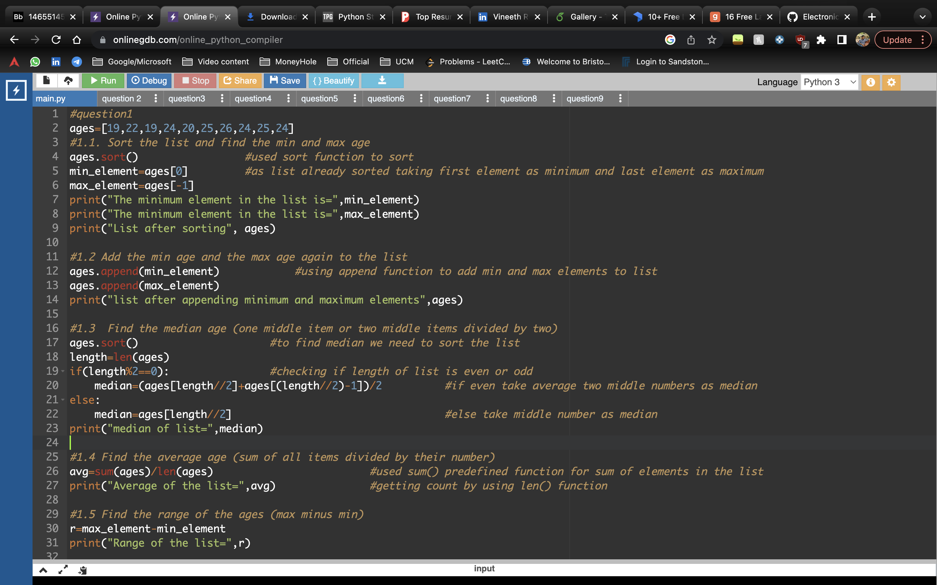

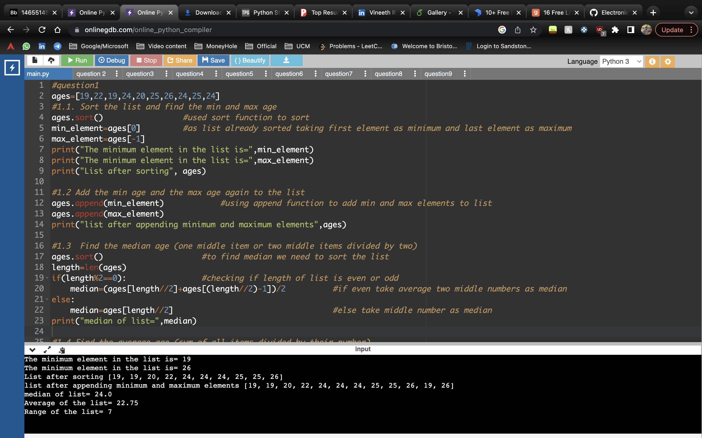

**Description:**

for question 1.1 used sort function to sort. As list already sorted taking first element as minimum and last element as maximum

for question 1.2 using append function to add min and max elements to list

for question 1.3 to find median we need to sort the list first. If number of items in the list are odd, we directly consider middle number as median else we take middle two numbers Average

for question 1.4 to find average we need sum of all numbers and count of numbers. Here we used sum() method and len() method to find them.

For question 1.5 range is difference between maximum value and minimum value. Stored range value in r and printed.

­­

**Question 2**

• Create an empty dictionary called dog

• Add name, color, breed, legs, age to the dog dictionary

• Create a student dictionary and add first_name, last_name, gender, age, marital status, skills, country, city and address as keys for the dictionary

• Get the length of the student dictionary

• Get the value of skills and check the data type, it should be a list

• Modify the skills values by adding one or two skills

• Get the dictionary keys as a list

• Get the dictionary values as a list

**Answer**

#question 2

#2.1 Create an empty dictionary called dog

dog={}

#2.2 Add name, color, breed, legs, age to the dog dictionary

#added values and keys accordingly

dog["name"]="Julie"

dog["breed"]="pug"

dog["color"]="black"

dog["legs"]=4

dog["age"]=1

#2.3 Create a student dictionary and add first_name, last_name, gender, age, marital status,

#skills, country, city and address as keys for the dictionary

student={"first_name":"Rahul",

"last_name":"M",

"gender":"Male",

"age":21,

"marital_status":"Single",

"Skills":["Java","SQL"],

"Country":"USA",

"Address":"Overland park"}

#2.4 Get the length of the student dictionary

length_student=len(student) #used len() predefined function to get student Length

print("Length of dictionary=",length_student)

#2.5 Get the value of skills and check the data type, it should be a list

print("skills are=",student["Skills"]) #accessing student skills using skills key

print("skills data type is=",type(student["Skills"])) #used type() to find data type

#2.6 Modify the skills values by adding one or two skills

student["Skills"].extend(["python","c"]) #added extra skill by extend() method as student["Skills"] is list

print("Skills after adding=",student["Skills"])

#2.7 Get the dictionary keys as a list

print("Keys present in student dict=",student.keys()) #to get keys in dictionary used keys() predined method

#2.8 Get the dictionary values as a list

print("values present in student dict=",student.values()) #to get values in dictionary used values() predfined method

**Screenshots**

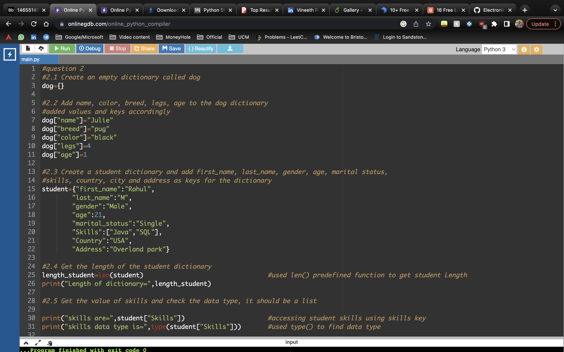

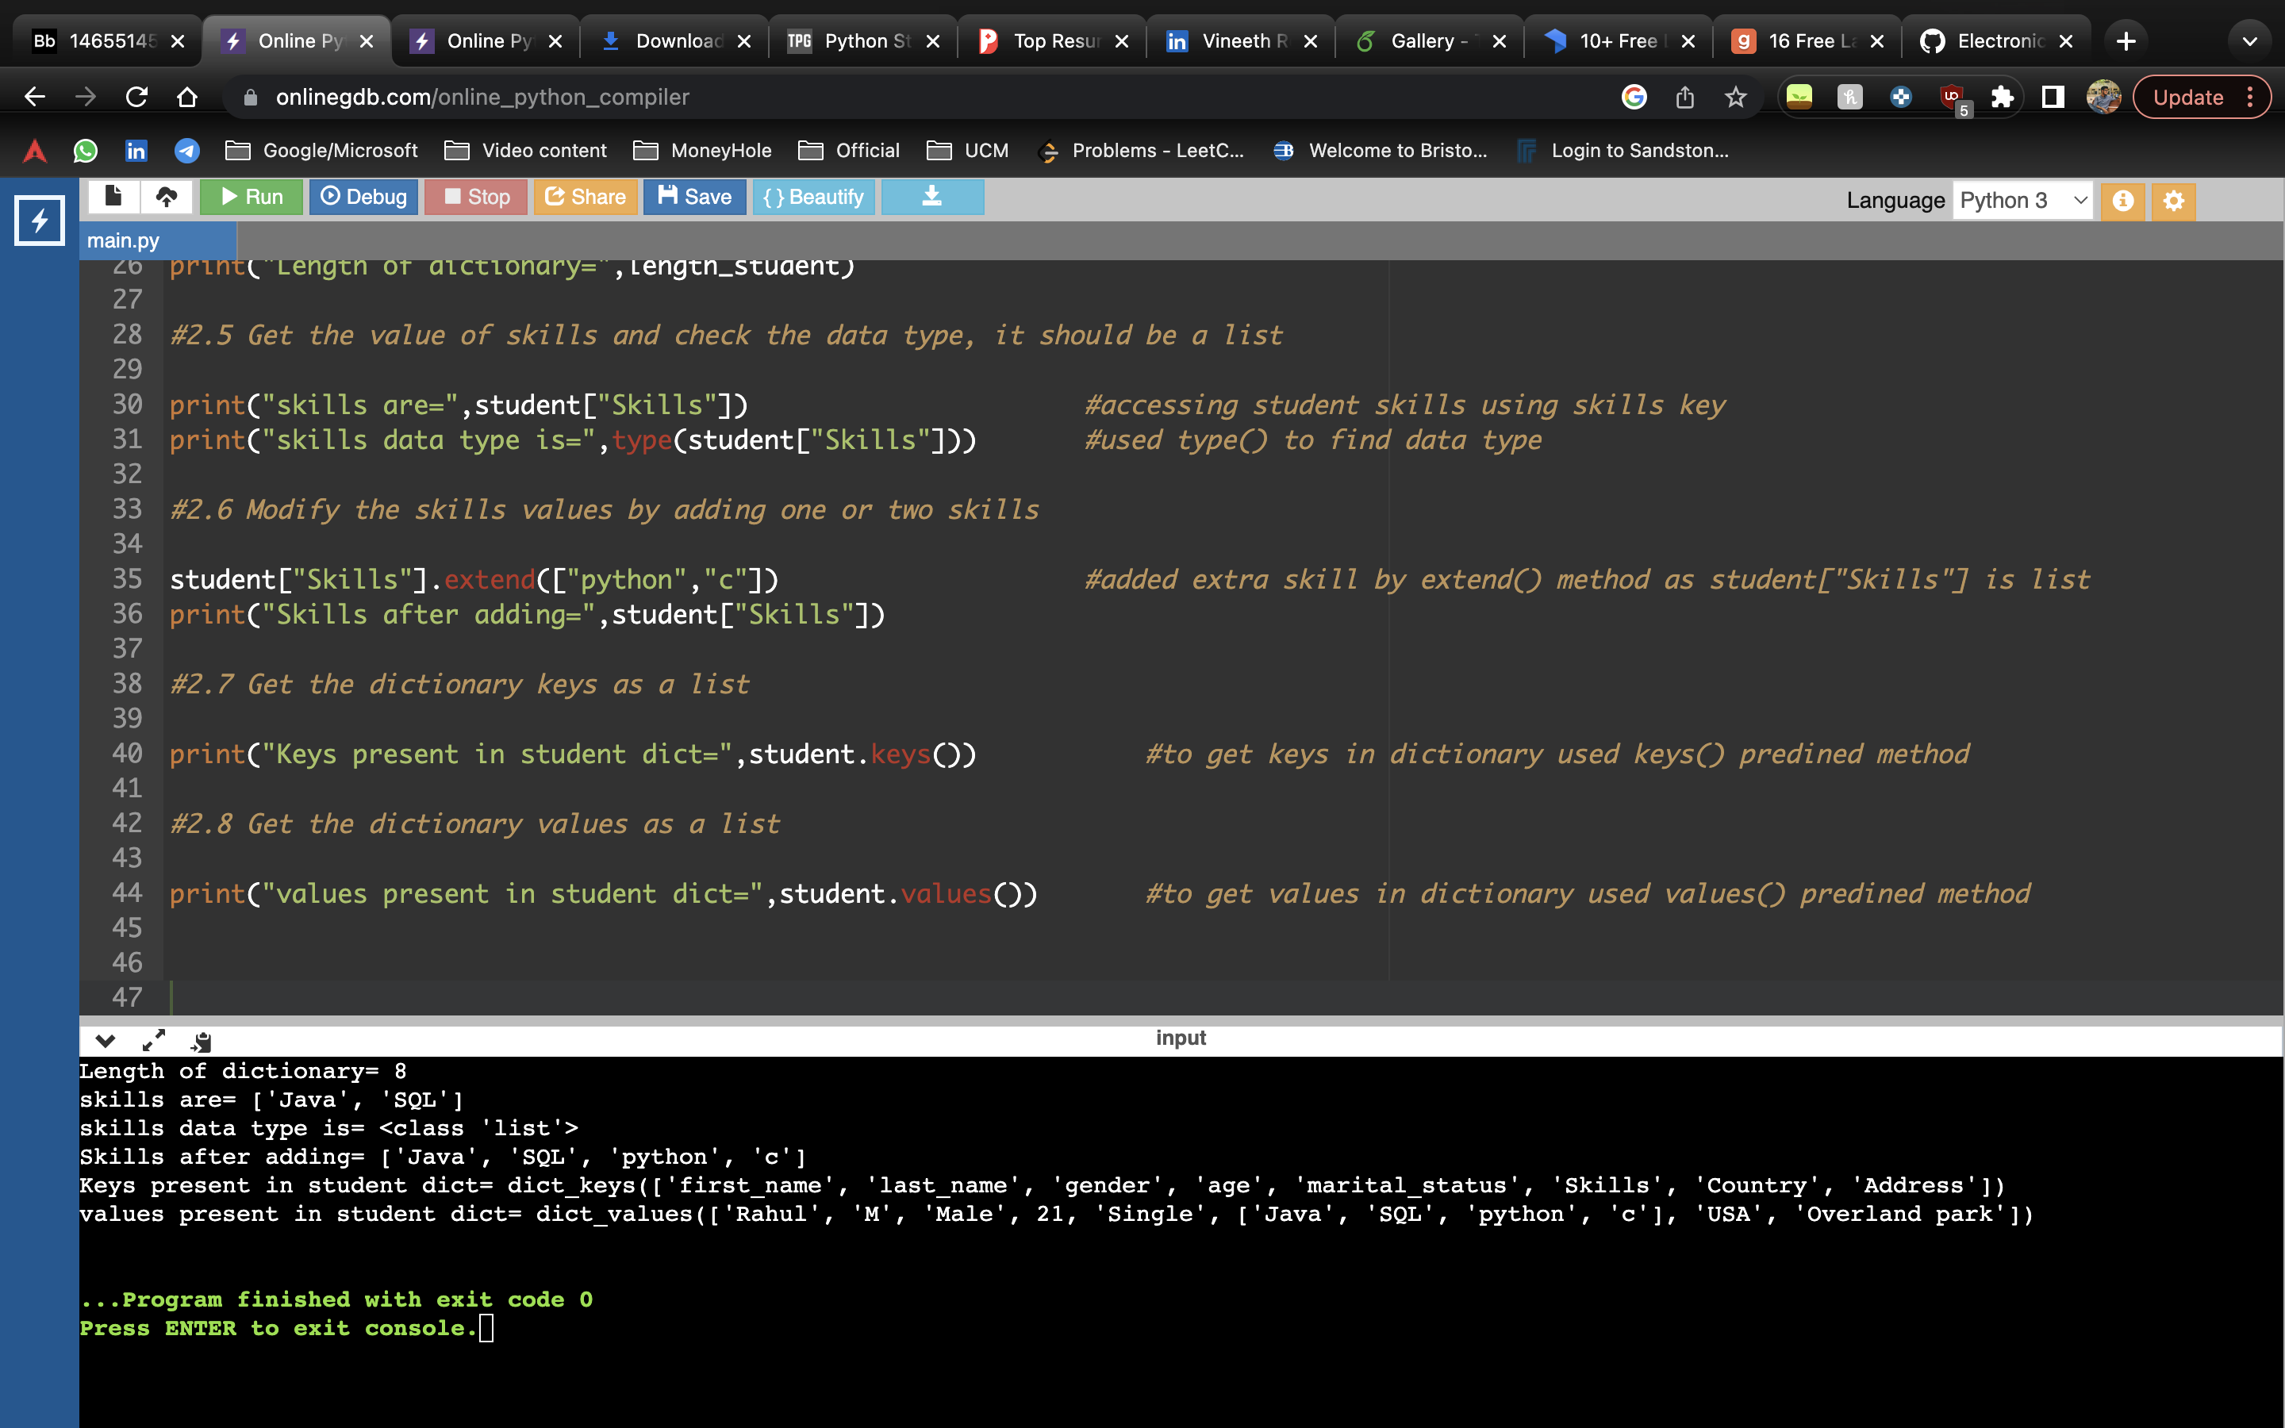

**Description**

Created an empty dictionary dog by initializing empty curly braces.

Added name, color, breed, legs, age to the dog dictionary , added values and keys accordingly

Created a student dictionary and added first_name, last_name, gender, age, marital status,

skills, country, city and address as keys for the dictionary and also added values at initialization itself

Same as list dictionary also have len() function which is used to find length of dictionary

For question 2.5 student["Skills"] accessing student skills using skills key which is of list type.

We can check data type by type() function in python.

To get keys in dictionary used keys() predefined method same as to get values in dictionary used values() predefined method

**Question 3**

• Create a tuple containing names of your sisters and your brothers (imaginary siblings are fine)

• Join brothers and sisters tuples and assign it to siblings

• How many siblings do you have?

• Modify the siblings tuple and add the name of your father and mother and assign it to family_members

**Answer**

#question3

#3.1 Create a tuple containing names of your sisters and your brothers

brothers=("harry","john")

sisters=("sam","meghan")

#3.2 Join brothers and sisters tuples and assign it to siblings

siblings=brothers+sisters #used + operator to join brothers and siblings tuples

print("siblings=",siblings)

#3.3 How many siblings do you have?

print("Number of siblings=",len(siblings)) #used len() predefined function to find count

#3.4 Modify the siblings tuple and add the name of your father and mother and assign it to family_members

#we cannot modify tuple as it is immutable

fatherName="SB"

motherName="VL"

family_members = siblings+(fatherName,motherName)

#added fatherName and motherName to siblings tuple and created a new tuple family_members

print("family numbers=",family_members)

**Screenshot**

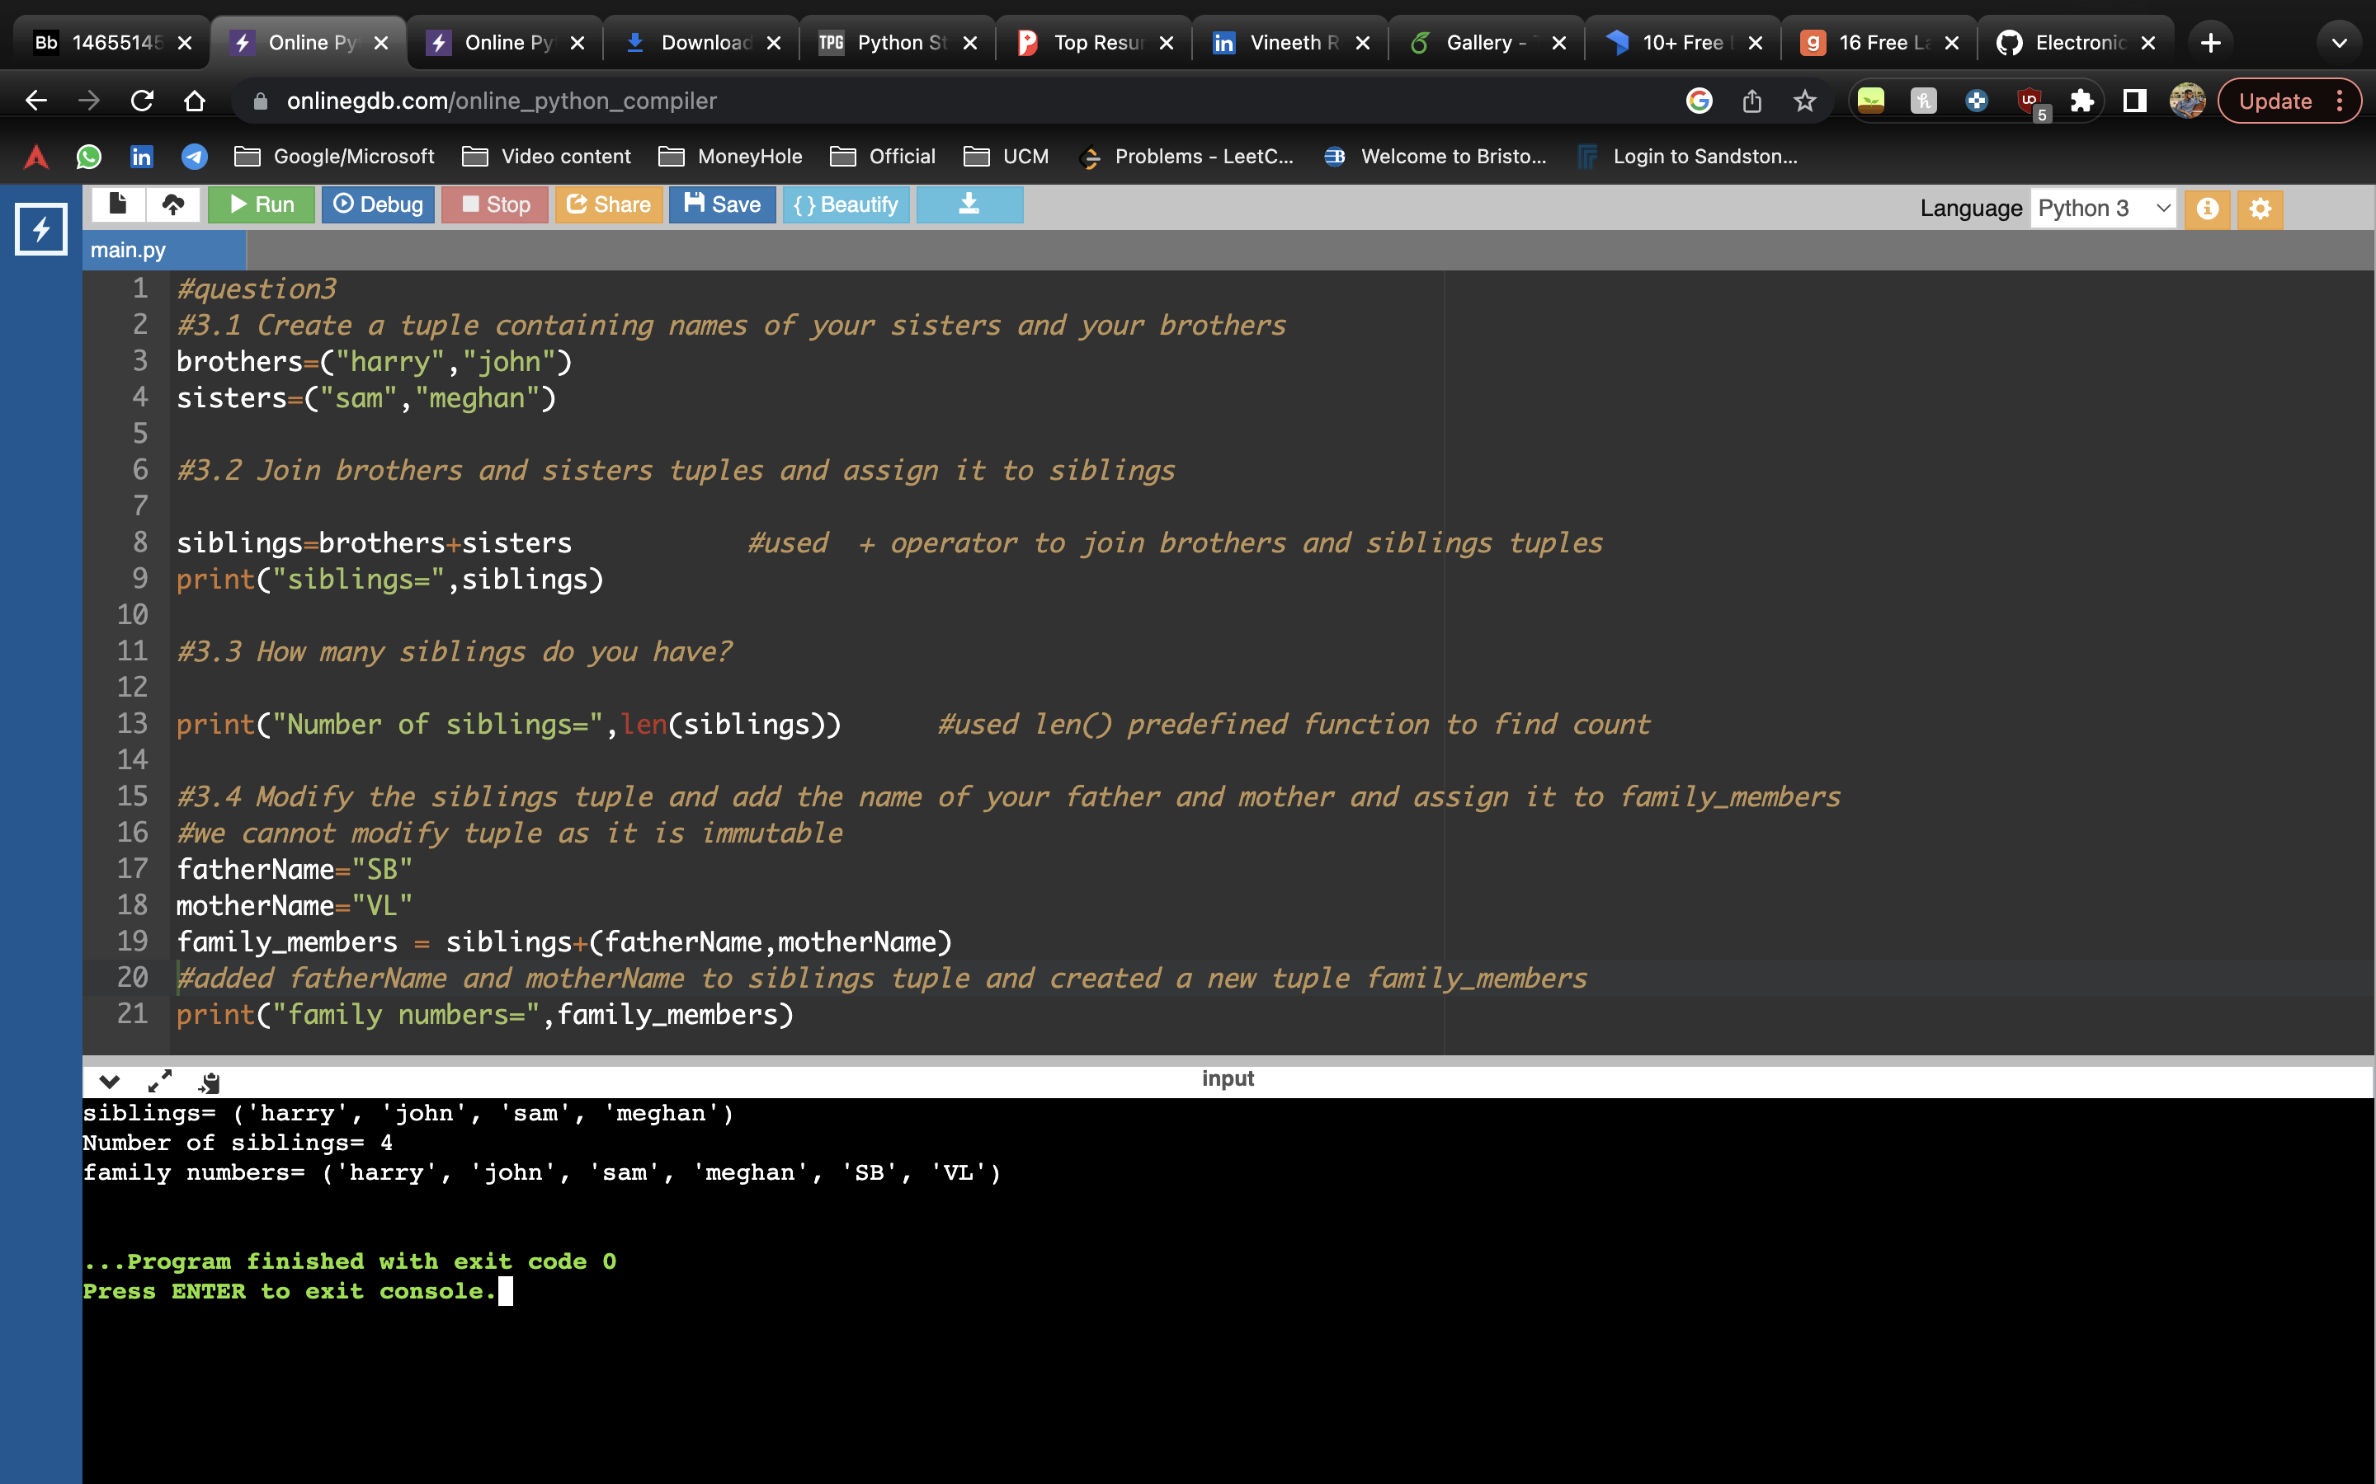

**Description**

To create a tuple we use round braces at initialisation where values are separated by comma. Created 2 tuples brothers and sisters

combined both tuples and stored in siblings variable and used len() to find count of siblings

as tuple cannot be modified to add fatherName and motherName created another tuple family_members and joined fatherName,motherName and siblings tuple

**Question 4**

it_companies = {'Facebook', 'Google', 'Microsoft', 'Apple', 'IBM', 'Oracle', 'Amazon'} A = {19, 22, 24, 20, 25, 26} B = {19, 22, 20, 25, 26, 24, 28, 27} age = [22, 19, 24, 25, 26, 24, 25, 24]

• Find the length of the set it_companies

• Add 'Twitter' to it_companies

• Insert multiple IT companies at once to the set it_companies

• Remove one of the companies from the set it_companies

• What is the difference between remove and discard

• Join A and B

• Find A intersection B

• Is A subset of B

• Are A and B disjoint sets

• Join A with B and B with A

• What is the symmetric difference between A and B

• Delete the sets completely

• Convert the ages to a set and compare the length of the list and the set.

**Answer:**

#question4

#4.1 Find the length of the set it_companies

it_companies = {'Facebook', 'Google', 'Microsoft', 'Apple', 'IBM', 'Oracle', 'Amazon'}

A = {19, 22, 24, 20, 25, 26}

B = {19, 22, 20, 25, 26, 24, 28, 27}

age = [22, 19, 24, 25, 26, 24, 25, 24]

print("length of it_companies=",len(it_companies)) #used len() to find length of it_companies set

#4.2 Add 'Twitter' to it_companies

it_companies.add("Twitter") #used add() predefined function to add twitter to it_companies

print("added twitter to set",it_companies)

#4.3 Insert multiple IT companies at once to the set it_companies

it_companies.update({"FEDEX","SAMSUNG"}) #to insert multiple values into set used update()

print("it_companies after adding multiple elements=",it_companies)

#4.4 Remove one of the companies from the set it_companies

it_companies.remove("Google") #remove() to remove item from set

print("it_companies after removing Google=",it_companies)

#4.5 What is the difference between remove and discard

'''Remove method throws Keyerror if the element is not present in the SET where as discard doesnt throw any error'''

#4.6 Join A and B

unionSet=A.union(B) #union() will return set contains all elements of A and B

print("Join of A and B=", unionSet)

#4.7 Find A intersection B

print("intersection of A and B=",A.intersection(B)) #intersection() returns a set of common values present in sets A and B

#4.8 Is A subset of B

print("Is A subset of B =",A.issubset(B)) #issubset() returns a boolean value of condition A subset of B or not

#4.9 Are A and B disjoint sets

print("Are A and B disjoint sets =",A.isdisjoint(B)) #isdisjoint() returns a boolean value of condition A and B are disjoint sets

#4.10 Join A with B and B with A

temp_A=A.copy() #stored A set in temporary set to keep its original values which can be used to join with B

A.update(B) #To join A with B

B.update(temp_A) #To join B with A

print("Join A with B =",A)

print("Join B with B =",B)

#4.11 What is the symmetric difference between A and B

A = {19, 22, 24, 20, 25, 26}

B = {19, 22, 20, 25, 26, 24, 28, 27}

#symmetric_difference() returns set which contains the elements which are either in set A or in set B but not in both

print("symmetric difference between A and B=",A.symmetric_difference(B))

#4.12 Delete the sets completely

del A #del permanently delete set

del B

#4.13 Convert the ages to a set and compare the length of the list and the set.

ages_set=set(age) #converting age list to set and storing in ages_set

print("age set =",ages_set)

print("length of ages set is =",len(ages_set)) #set removes repeated elements so length decreases

print("length of ages list is =",len(age))

**Screenshots:**

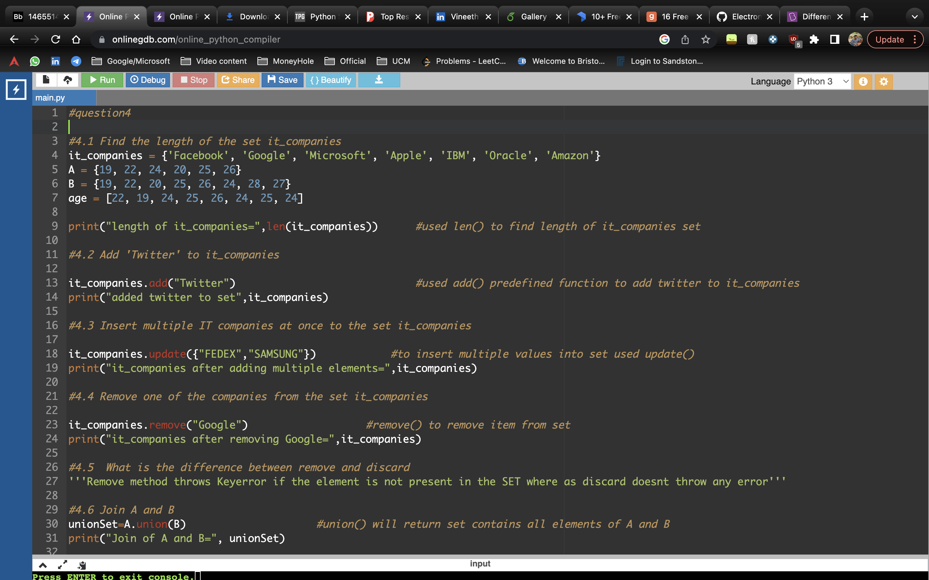

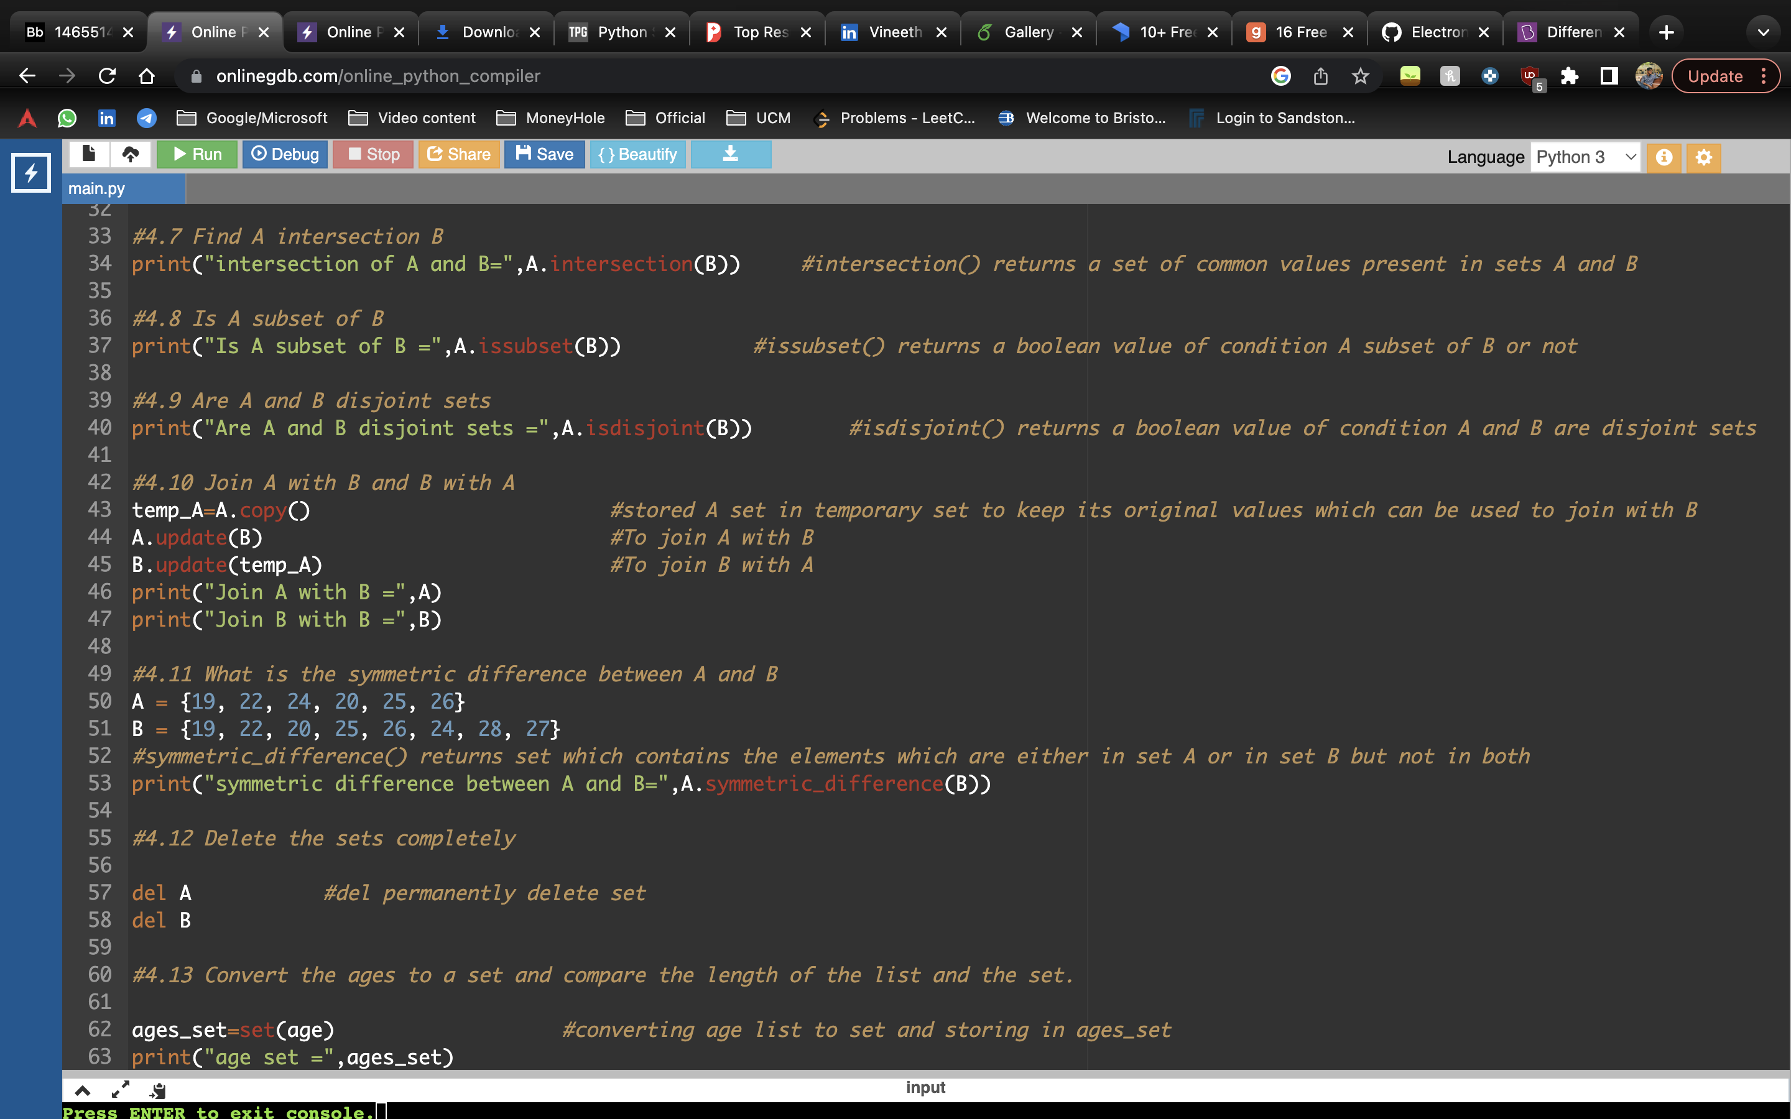

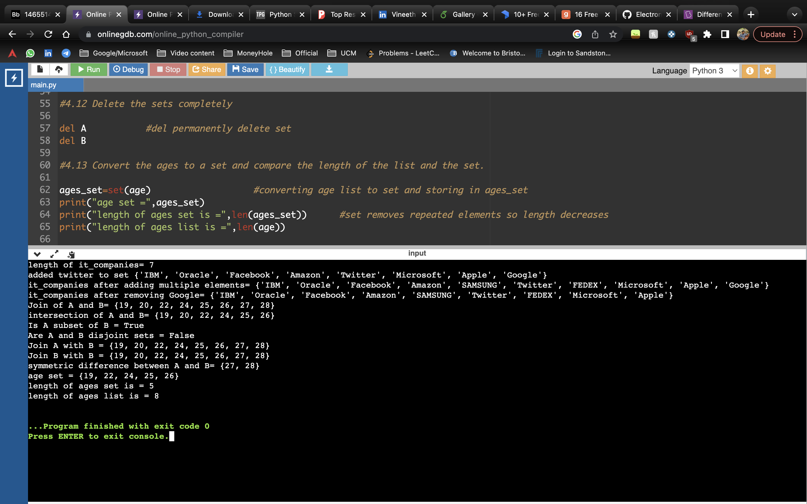

**Description**

Set is unordered list but we can use len() to find length of it_companies set and used add() predefined function to add twitter to it_companies

to insert multiple values into set used update() added FEDEX and SAMSUNG and remove() to remove item from set

And to join two sets A and B used union() method. union() will return set contains all elements of A and B. intersection() returns a set of common values present in sets A and B

A.issubset(B) returns a Boolean value of condition, A subset of B or not. A.isdisjoint(B) returns a Boolean value of condition A and B are disjoint sets

A.symmetric_difference(B) returns set which contains the elements which are either in set A or in set B but not in both.

to delete permanently we use del keyword

for question 4.13 converting age list to set and storing in ages_set by set() function.set removes repeated elements. so when lengths are compared, ages_set length is lower than ages list.

**Question 5**

The radius of a circle is 30 meters.

• Calculate the area of a circle and assign the value to a variable name of _area_of_circle_

• Calculate the circumference of a circle and assign the value to a variable name of _circum_of_circle_

• Take radius as user input and calculate the area.

**Answer**

#question5

from math import pi # imported pi variable from math library

radius=30

#5.1 Calculate the area of a circle and assign the value to a variable name of _area_of_circle_

_area_of_circle_ = pi * radius * radius #as area of circle is π × radius2

print("Area of circle = ",round(_area_of_circle_,2))

#5.2 Calculate the circumference of a circle and assign the value to a variable name of _circum_of_circle_

_circum_of_circle_ = 2 * pi * radius #as circumference of circle is 2 x π × radius

print("circumference of circle = ",round(_circum_of_circle_,2))

#5.3 Take radius as user input and calculate the area.

radius=int(input("Enter radius of circle =")) #took radius as input from user

_area_of_circle_ = pi * radius * radius #as area of circle is π × radius2

print("Area of circle = ",round(_area_of_circle_,2))

**Screenshot**

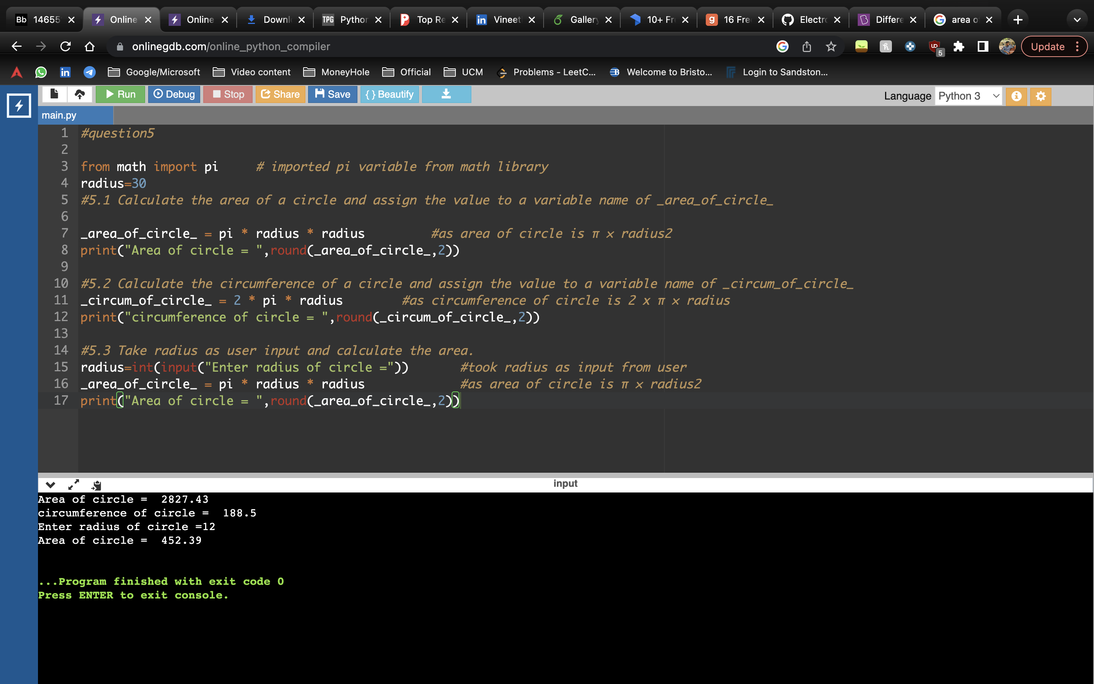

**Description**

Imported pi variable from math library

Calculated area of a circle and assigned it to a variable _area_of_circle_ using area of a circle formula.

Calculated circumference of a circle and assigned it to a variable _circum_of_circle_ using circumference of a circle formula.

Now, took the input of radius from the user.

Calculated the area of circle again with the user input.

**Question 6**

“I am a teacher and I love to inspire and teach people”

• How many unique words have been used in the sentence? Use the split methods and set to get the unique words

**Answer**

#question6

string = "I am a teacher and I love to inspire and teach people"

string=string.split() #split() Split string into a list where each word is a list item as space as separator

#to remove repeated elements we can convert list to set so that repeated elements will be removed

string=set(string)

print("Number of unique words present are =",len(string)) #as set contains only unique elements len() returns count of unique words

**Screenshot**

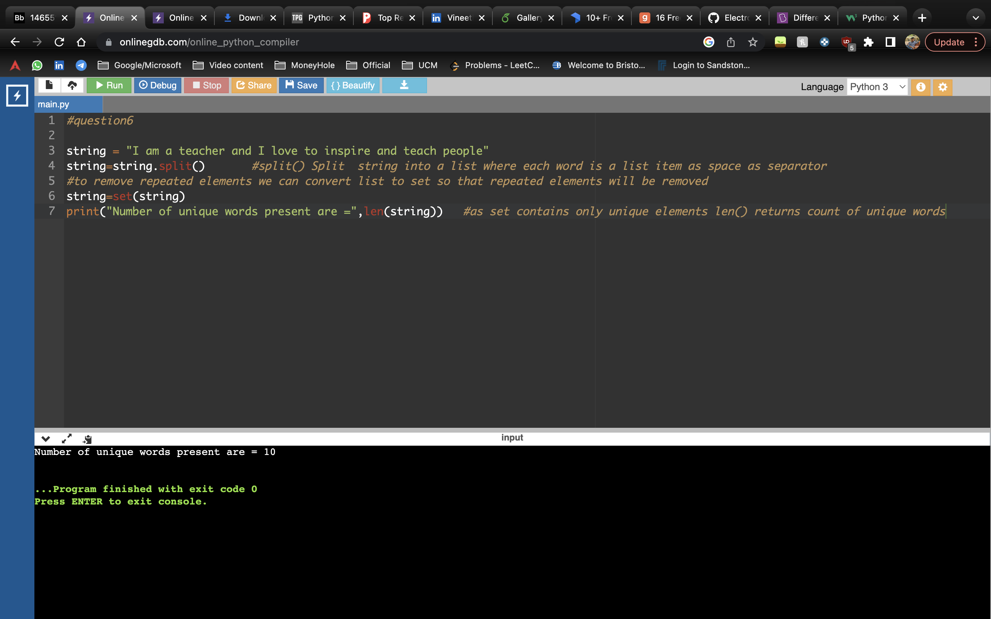

**Description**

Given a sentence, have stored it in a variable x.

Using split() method, I have split the sentence, it converts to a list and stored it in string.

We convert this list to set to remove the duplicate element using set(). set() is used to get the unique words from the list.

For knowing no. of unique words used, used len() function.

**Question 7**

Use a tab escape sequence to get the following lines.

Name Age Country City

Asabeneh 250 Finland Helsinki

**Answer**

#question7

print("Name\t\tAge\t\tCountry\t\tCity") #\t gives tab space(4 spaces)

print("Asabeneh\t250\t\tFinland\t\tHelsinki") #print() prints the line and move to next line in console, or we can use \n

**Screenshot**

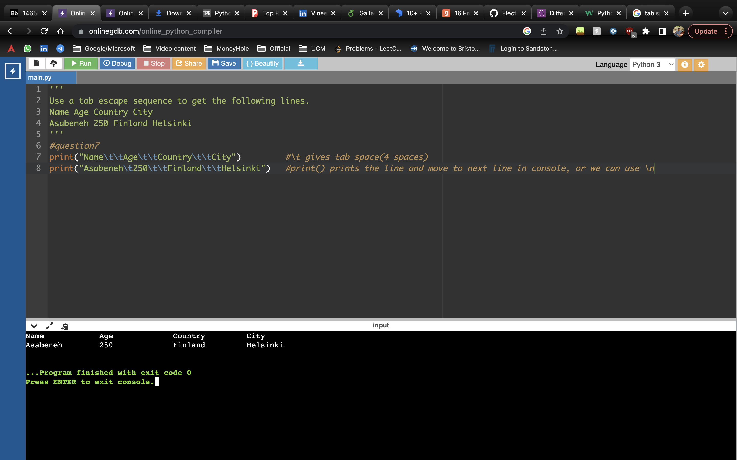

**Description**

Using tab escape sequence printed the above lines.

\t – for a tab space

print() prints the line and move to next line in console, or we can use \n

**Question 8**

Use the string formatting method to display the following:

radius = 10

area = 3.14 * radius ** 2

“The area of a circle with radius 10 is 314 meters square.”

**Answer**

'''

Question 8

Use the string formatting method to display the following:

radius = 10

area = 3.14 * radius ** 2

“The area of a circle with radius 10 is 314 meters square.”

'''

#using .format() for string formatting and used placeholders in curly braces to format string

print("radius = {radius}".format(radius=10))

print("area = {pi} * {radius} ** 2".format(pi=3.14,radius=10))

radius = 10

area = 3.14 * radius ** 2

# used precision of the floating-point values for area :.0f

print("The area of a circle with {radius} is {area:.0f} meters square.".format(radius=radius,area=area))

**Screenshot**

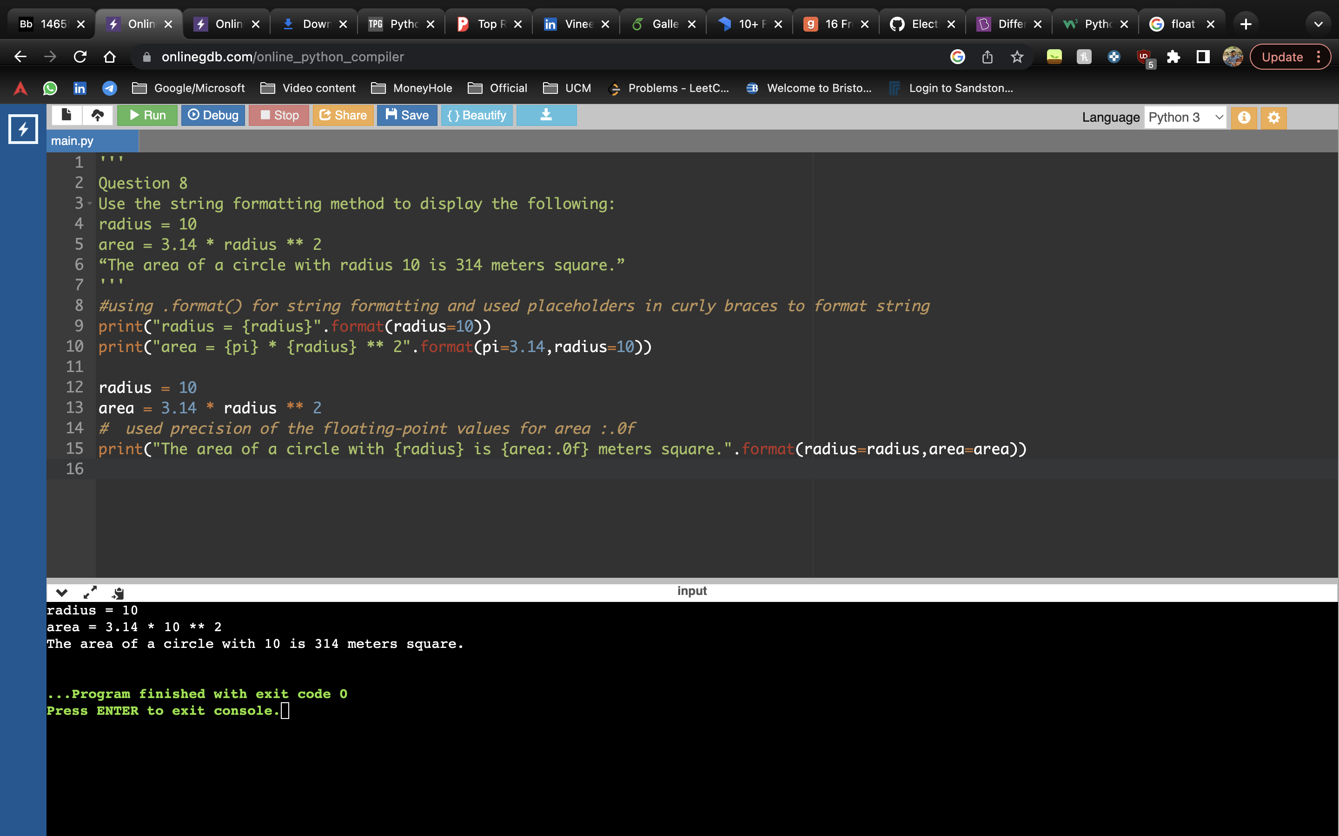

**Description**

Used .format() for string formatting and used placeholders in curly braces to format string. Used precision of the floating-point values for area :.0f

**Question 9**

Write a program, which reads weights (lbs.) of N students into a list and convert these weights to

kilograms in a separate list using Loop. N: No of students (Read input from user)

Ex: L1: [150, 155, 145, 148]

Output: [68.03, 70.3, 65.77, 67.13]

**Answer**

#Question9

N=int(input("Enter number students:")) #N is number of students

student_weight_lb=[] #list to store student weight in pounds

student_weight_kg=[] #list to store student weight in kilograms

while(N): #used while loop to take list of weights from console

weight=int(input())

student_weight_lb.append(weight)

N=N-1

for weight in student_weight_lb: #iterated through student_weight_lb list by using 'for' loop

kg=round(weight*0.454,2) #conversion of pounds to kg and rounding decimal values

student_weight_kg.append(kg) # adding converted value to student_weight_kg list

print(student_weight_kg)

**Screenshot**

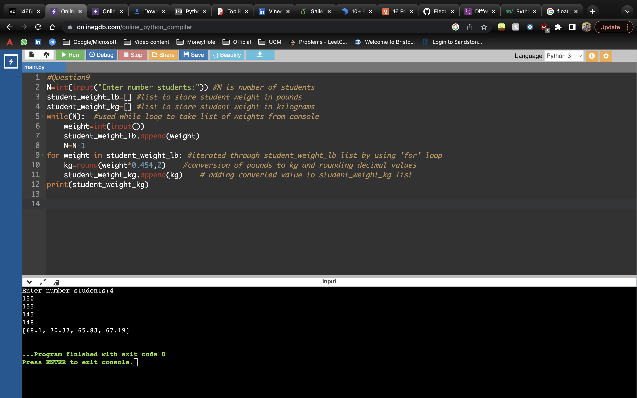

**Description**

N is number of students

Created a list to store student weight in pounds

Created a list to store student weight in kilograms

Used while loop to take list of weights from console

Iterated through student_weight_lb list by using 'for' loop

Conversion of pounds to kg and rounding decimal values

Added converted value to student_weight_kg list

**Question 10**

The diagram below shows a dataset with 2 classes and 8 data points, each with only one feature value, labeled f. Note that there are two data points with the same feature value of 6. These are shown as two x’s one above the other. Provide stepwise mathematical solution, do not write code for it.

1. Divide this data equally into two parts. Use first part as training and second part as testing. Using KNN classifier, for K=3, what would be the predicted outputs for the test samples? Show how you arrived at your answer.

2. Compute the confusion matrix for this and calculate accuracy, sensitivity and specificity values

**Answer**

